BDO India LLP
As-Is analysis of UPSRLM Training Management and Reporting Cycle Key Process Steps: 1. Annual Action Planning (AAP) Process 2. Training Execution Process Recording Period: 12th September 2025 to 17th September 2025
U.P. STATE RURAL LIVELIHOODS MISSION Lucknow, Uttar Pradesh

Document Details
Project Name | As-Is Process Study-UPSRLM Training Management and Reporting Cycle
Date: | 12-09-2025 | Release | Ver 1.0
Author | Ayush M Srivastava
Owner | BDO India LLP
Client | U.P. State Rural Livelihoods Mission (PRERNA)
Document Number | BDO-UPSRLM-AIPS-v1-TMS’2025

Approvals
Name | Title | Date of Issue | Version
Sachin A Kumar | Project Manager-BDO India LLP | 17-09-2025 | 1.0
Team BDO |  |  | 1.0

Distribution
Name | Title | Date of Issue | Version
Ms. Deepa Ranjan | Mission Director (MD), UPSRLM | 17-09-2025 | 1.0
Ms. Niti Shrivastav | Joint Mission Director (JMD), UPSRLM | 17-09-2025 | 1.0

Table of Contents
1. Introduction 3
- 1.1. Governance and the Administrative Support Structure for Training 3
- 1.2. Thematic Leadership and Reporting Relationships 3
- 1.3. Delegation of Administrative and Financial Powers 4
2. Strategic Planning: The Annual Action Plan (AAP) and Budgetary Workflows 5
- 2.1. The Bottom-Up Planning Cycle 5
- 2.2. Budgetary Control and Fund Flow Mechanism 5
- 2.3. Annual Action Planning (AAP) Process 8
2.3.1. Objective 8
2.3.2. Process Steps 8
2.3.3. Organizational Levels Involved 8
2.3.4. Identified Delays 8
- Annual Action Planning (AAP) Process Map 9
3. Training Execution Process 10
- 3.1. The Sourcing and Empanelment of Training Personnel 10
- 3.2. Recruitment of Mission Staff 10
- 3.3. Empanelment of Resource Persons and Master Trainers 10
- 3.4. Community-Level Capacity Building: Standardized Training Modules 10
- 3.5. Training Modules for SHG and VO Members 10
- 3.6. Specialized Training for Community Cadres 11
- 3.7. Operational Workflows and Training Execution Logistics 11
3.7.1. Objective 11
3.7.2. Process Steps 11
3.7.3. Organizational Levels Involved 11
- Training Execution Process Map 12
4. Summary of Key Findings 13

- Introduction
The institutional framework of the Uttar Pradesh State Rural Livelihood Mission (UPSRLM) is predicated on the fundamental principle that the rural poor possess an inherent capacity for self-improvement and economic resilience, provided they are supported by a dedicated, external structure capable of facilitating social mobilization and empowerment.
Training management is the central nervous system of this mission, serving as the primary vehicle through which professional expertise is translated into community-level action. Within the broader context of the Deendayal Antyodaya Yojana – National Rural Livelihoods Mission (DAY-NRLM), UPSRLM operates as the implementing arm in Uttar Pradesh, establishing a multi-tiered architecture of Self-Help Groups (SHGs), Village Organizations (VOs), and Cluster Level Federations (CLFs).
This report provides an exhaustive mapping of the current as-is processes governing training management, ranging from strategic planning and human resource procurement to financial settlement and technological reporting.
Recording Period:
10th September 2025 to 25th September 2025

  - Governance and the Administrative Support Structure for Training
The efficacy of training delivery is contingent upon a highly structured administrative hierarchy that ensures vertical alignment and technical fidelity across the state.
The Mission operates through three distinct levels of management:
- The State Mission Management Unit (SMMU)
- The District Mission Management Unit (DMMU)
- The Block Mission Management Unit (BMMU).
Each level possesses specific mandates regarding the conceptualization, execution, and monitoring of capacity-building initiatives.

  - Thematic Leadership and Reporting Relationships
The SMMU functions as the strategic headquarters, led by the Joint Mission Director (JMD), Additional Mission Director (AMD) and the Mission Director (MD). Training and capacity building are primarily the domain of the State Mission Manager (SMM), who coordinates with other thematic heads such as those for Financial Inclusion (FI) and Livelihoods.
These functional anchors are responsible for the development of training modules, the selection of training agencies, and the establishment of quality standards.
At the district level, the District Mission Manager (DMM) serves as the team leader for the DMMU, reporting to the SMMU while overseeing the functional anchors within the district. The BMMU, led by the Block Mission Manager (BMM), represents the cutting-edge unit that works directly with community institutions. The reporting relationship is designed to be both administrative and functional; for example, a training officer at the block level reports administratively to the BMM but works in close technical coordination with the DMM at the district level.

Level | Key Training Personnel | Primary Role in Training Lifecycle
State | State Mission Manager (SMM) | Strategy, Policy, and Module Development
District | District Mission Manager (DMM) | Coordination, Monitoring, and Fund Disbursement
Block | Block Mission Manager (BMM) | Mobilization, Logistics, and Field Execution
Field | Training Partners, Community Resource Persons (CRPs), Master Trainers (DRPs, BRPs) | Direct Training Delivery to Community

  - Delegation of Administrative and Financial Powers
The mission adheres to a policy of decentralized empowerment to ensure operational efficiency. Administrative and financial powers are largely delegated to the DMMU and BMMU levels to enable quick responses to field demands. This delegation allows district and block units to approve localized training schedules, manage participant logistics, and process minor expenditures.
However, larger thematic interventions and state-wide training programs remain under the centralized control of the SMMU to ensure uniformity in training quality. The FMTSA (Financial Management Technical Support Agency) provides critical support to the Chief Financial Accounts Officer (CFAO) at the State, assisting in the preparation of bank reconciliations and ensuring that all training-related financial transactions are synchronized through the Tally accounting system.
- Strategic Planning: The Annual Action Plan (AAP) and Budgetary Workflows
The Training management at UPSRLM is not an ad hoc activity but is integrated into a rigorous annual planning cycle known as the Annual Action Plan (AAP). This process follows a bottom-up methodology, ensuring that training inputs are aligned with the actual needs of the community institutions.

  - The Bottom-Up Planning Cycle
The AAP process is initiated between December and January for the upcoming financial year. It begins at the Village Organization (VO) level, where the Executive Committee (EC) members identify the training needs of their constituent SHGs. These VO-level plans are then consolidated by the Cluster Level Federation (CLF) nodal officer. The CLF incorporates its own strategic goals, such as leadership rotation or business development planning, into the consolidated document.
Milestone | Actor Responsible | Completion Timeline (Tentative)
VO Planning Initiation | VO Executive Committee | 1st/2nd Week of December
VO Plan Completion | BMM Support | By January 15th
CLF Consolidation | CLF Nodal Officer | Within February
District Target Setting | DMM | Late February
State-Level AAP Approval | SMMU | March
The CLF Business Planning process is anchored by a visioning exercise (Vision, Mission, Objectives, Strategy, and Activities - VMOSA), which dictates the training priorities for the year. To ensure the quality of this planning, the mission mandates that the CLF Nodal Officer must attend at least 30% of the VO planning sessions, while the DMM must verify at least 10% of the CLF-level sessions.
  - Budgetary Control and Fund Flow Mechanism
Once the AAP is finalized, the financial aspects are managed through the Public Financial Management System (PFMS) and the Single Nodal Agency (SNA) framework.
The FMTSA facilitates the allotment of funds to districts based on their physical targets. Expenditure reporting is conducted through Tally, with entries made according to specific budget heads corresponding to various training themes. This system allows the mission to track expenditure in real-time and ensures that training funds are not diverted to other administrative costs.
The preparation of Utilization Certificates (UCs) is a critical step in this workflow, as they are required for the release of subsequent funding installments from the National Rural Livelihoods Mission (NRLM).

  - Annual Action Planning (AAP) Process
    - Objective
To define the training needs and allocate resources for the upcoming financial year.
    - Process Steps
- VO EC Identifies Needs: (VO/CLF) - Village Organization Executive Committee identifies training needs of SHGs.
- BMM Support: (BMMU) - Block Mission Management Unit provides support to VOs in planning.
- CLF Consolidates: (VO/CLF) - Cluster Level Federation consolidates VO plans.
- VMOSA Review: (VO/CLF) - CLF conducts a Vision, Mission, Objectives, Strategy, and Activities review.
- DMM Sets Targets: (DMMU) - District Mission Management Unit sets district-level targets.
- District AAP: (DMMU) - District Annual Action Plan is created.
- SMMU Approval? (SMMU) - State Mission Management Unit reviews and approves the AAP.
- Decision: Is the AAP approved?
- No: Revise AAP (Goes back to step 6).
- Yes: AAP Approved (Proceeds to step 8).
- AAP Approved: (SMMU) - The Annual Action Plan is officially approved.
- FMTSA Allocates: (FMTSA) - Financial Management Technical Support Agency allocates funds.
- PFMS Funds to Districts: (FMTSA) - Funds are transferred to districts via the Public Financial Management System.
    - Organizational Levels Involved
- VO/CLF
- BMMU
- DMMU
- SMMU
- FMTSA
    - Identified Delays
- Late finalization of District AAP (Late Feb)
- SMMU Approval Process

Annual Action Planning (AAP) Process Map
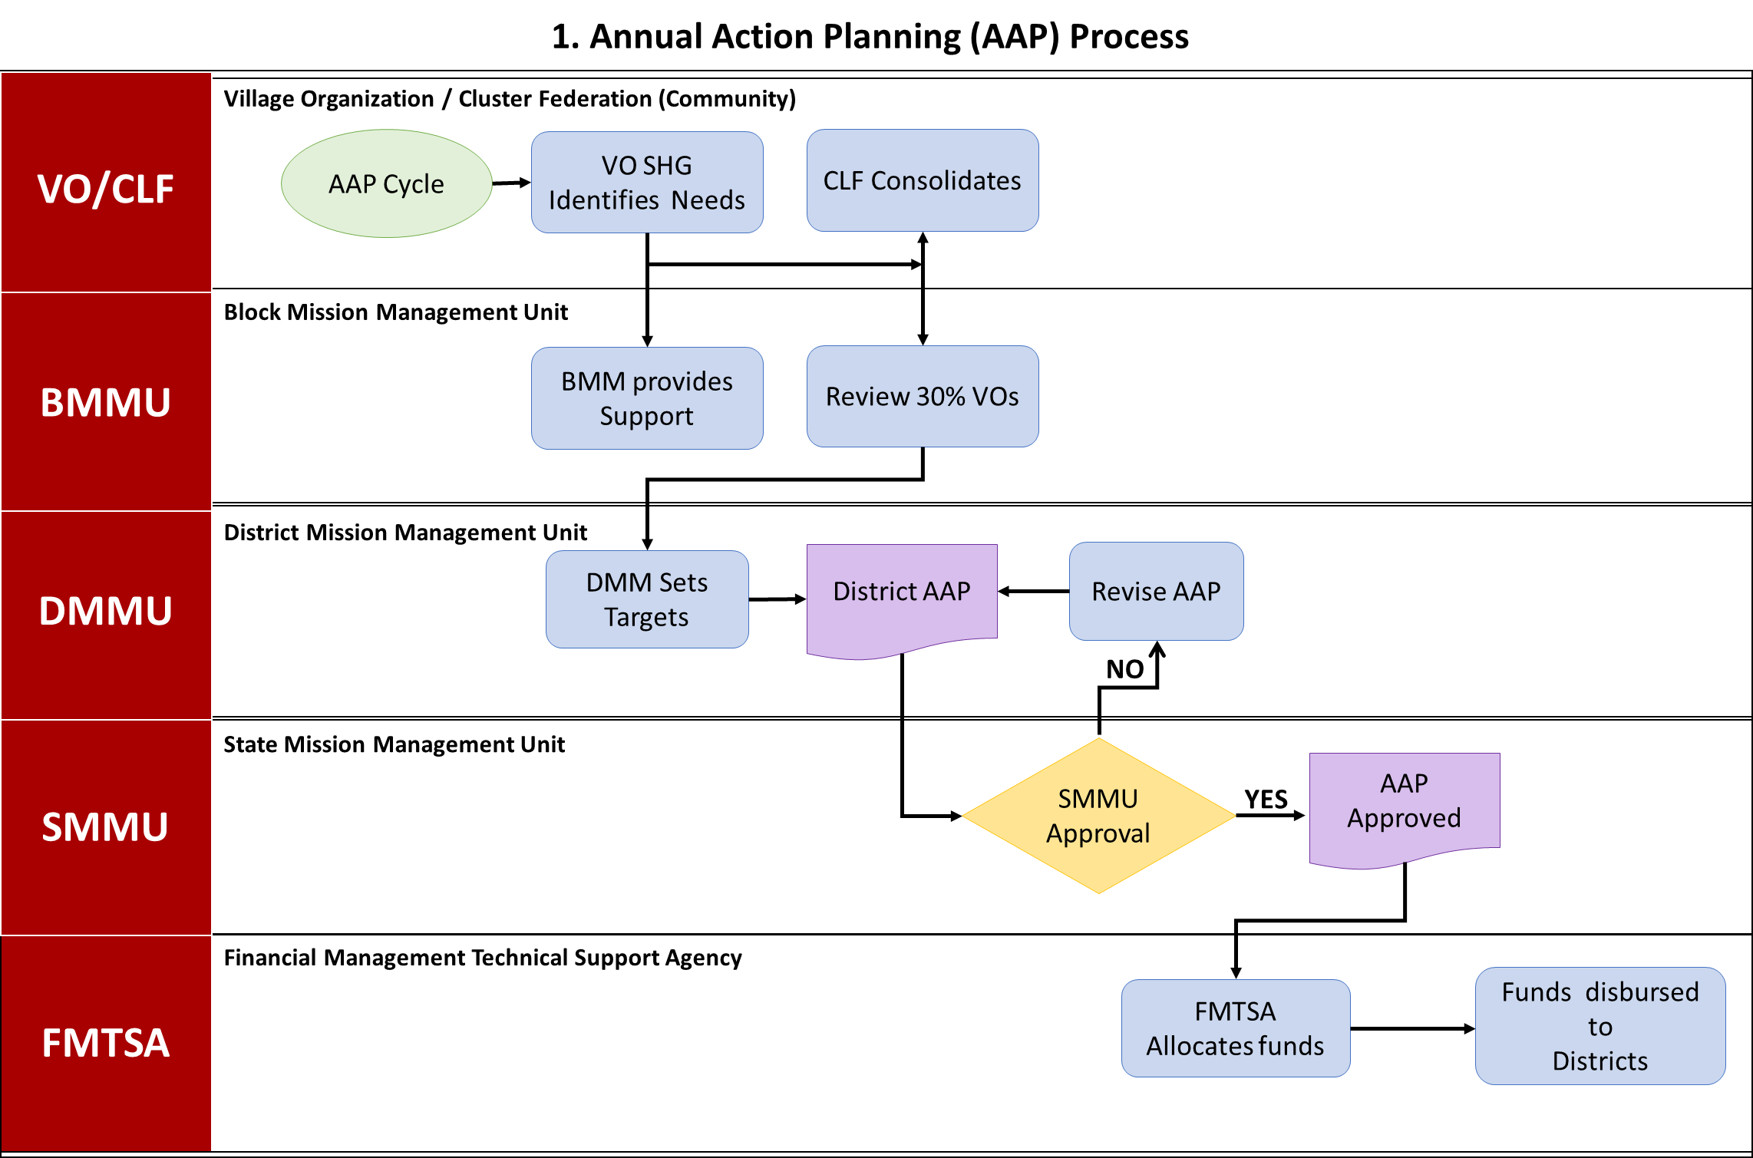

- Training Execution Process
  - The Sourcing and Empanelment of Training Personnel
The quality of capacity building is directly linked to the expertise of the resource pool. UPSRLM employs a systematic empanelment process to recruit both staff and external resource persons.
  - Recruitment of Mission Staff
Staff recruitment at all levels—State, District, and Block—is carried out in a phased manner, ensuring that candidates are inducted and immersed in the mission's values and philosophy. The mission may hire HR agencies to manage the recruitment process, adhering to procurement norms. For newly joined staff, particularly the thematic anchors, the mission enforces a 10-15 day induction and immersion program. This program involves classroom sessions followed by "village immersion," where staff stay in rural hamlets to gain a first-hand understanding of the socio-economic challenges faced by the poor.
  - Empanelment of Resource Persons and Master Trainers
Beyond permanent staff, UPSRLM maintains a pool of Resource Persons at the state, district, and block levels. These individuals are selected based on intensive experience in forming and strengthening SHGs and their federations.
Criteria Category | Requirement
Education | Graduate or equivalent in relevant fields (Social Science, Rural Management)
Experience | 5+ years with empanelled agencies (PRADAN, MYRADA, etc.)
Technical Skills | Participatory training, behavior change communication, TNA
Selection Process | Public advertisement, resume shortlisting, personal interview

In 2024 and 2025, various districts such as Prayagraj, Deoria, and Hathras issued revised recruitment notices for District Resource Persons (DRPs) and Block Resource Persons (BRPs). These personnel are tasked with conducting Training of Trainers (TOT) and facilitating generic staff induction. Their empanelment is subject to periodic reviews, and their remuneration is governed by NRLM cost norms.
  - Community-Level Capacity Building: Standardized Training Modules
At the heart of the training management process are the standardized modules designed for community cadres and SHG members. These modules are developed to ensure that the "institutional memory" of the community institutions remains robust even as leadership rotates.
  - Training Modules for SHG and VO Members
The training for SHG members begins with Module 0, which focuses on the initial formation and meeting protocols. This is followed by a sequence of modules covering concept management, credit linkages, and financial inclusion. As the members transition to higher-level federations, the training becomes more complex, focusing on the management of Village Organizations and the Participatory Identification of the Poor (PIP).
For Village Organizations, specific training is provided on the concept of sub-committees, gender and women's empowerment, and the management of the Community Investment Support Fund (CIF). These modules are delivered by Community Resource Persons (CRPs) who undergo their own specialized training cycles.

  - Specialized Training for Community Cadres
Community cadres, such as bookkeepers and Samuh Sakhis, are essential for the financial transparency of the SHGs. Bookkeepers undergo a 14-day training program spread over a year, focusing on the maintenance of basic records and financial literacy. Samuh Sakhis are trained on the NRLM resource block strategy, ensuring they can effectively mobilize and support newly formed SHGs in their villages.
Target Cadre | Key Training Modules | Delivery Mechanism
SHG Members | Module I: Concept & Mgmt, Module II: Credit Linkages | External/Internal CRPs
VO Leaders | Module IV: Financial/CIF Mgmt, Module VI: Social Action | Training of Trainers (TOT)
CRPs | Module III: CISF Management, Module V: Micro Credit Plan | Modular training (M1-M3)
Bookkeepers | SHG/VO/CLF Bookkeeping and Auditing | District-level workshops

The training for CRPs is modular, often designated as M1, M2, and M3. For example, records indicate that CRP teams provided these modular trainings to thousands of potential SHGs across various blocks, emphasizing the scale of the mobilization effort.
  - Operational Workflows and Training Execution Logistics
    - Objective
To conduct training programs based on the approved AAP.
    - Process Steps
- Training Need: (BMMU) - A specific training need is identified.
- Mobilize Participants: (BMMU) - Participants are mobilized for the training.
- Procure Kits: (BMMU) - Training kits and materials are procured.
- Venue Setup: (Training Partner) - A suitable venue is set up for the training.
- Deploy CRPs: (BMMU) - Community Resource Persons are deployed to conduct the training.
- Conduct Training: (Training Partner) - The training program is conducted.
- MIS Entry: (BMMU) - Training data is entered into the Management Information System.
- Completion Report: (BMMU) - A training completion report is generated.
    - Organizational Levels Involved
- STP
- BMMU
- DMMU
- SMMU
- FMTSA

Training Execution Process Map
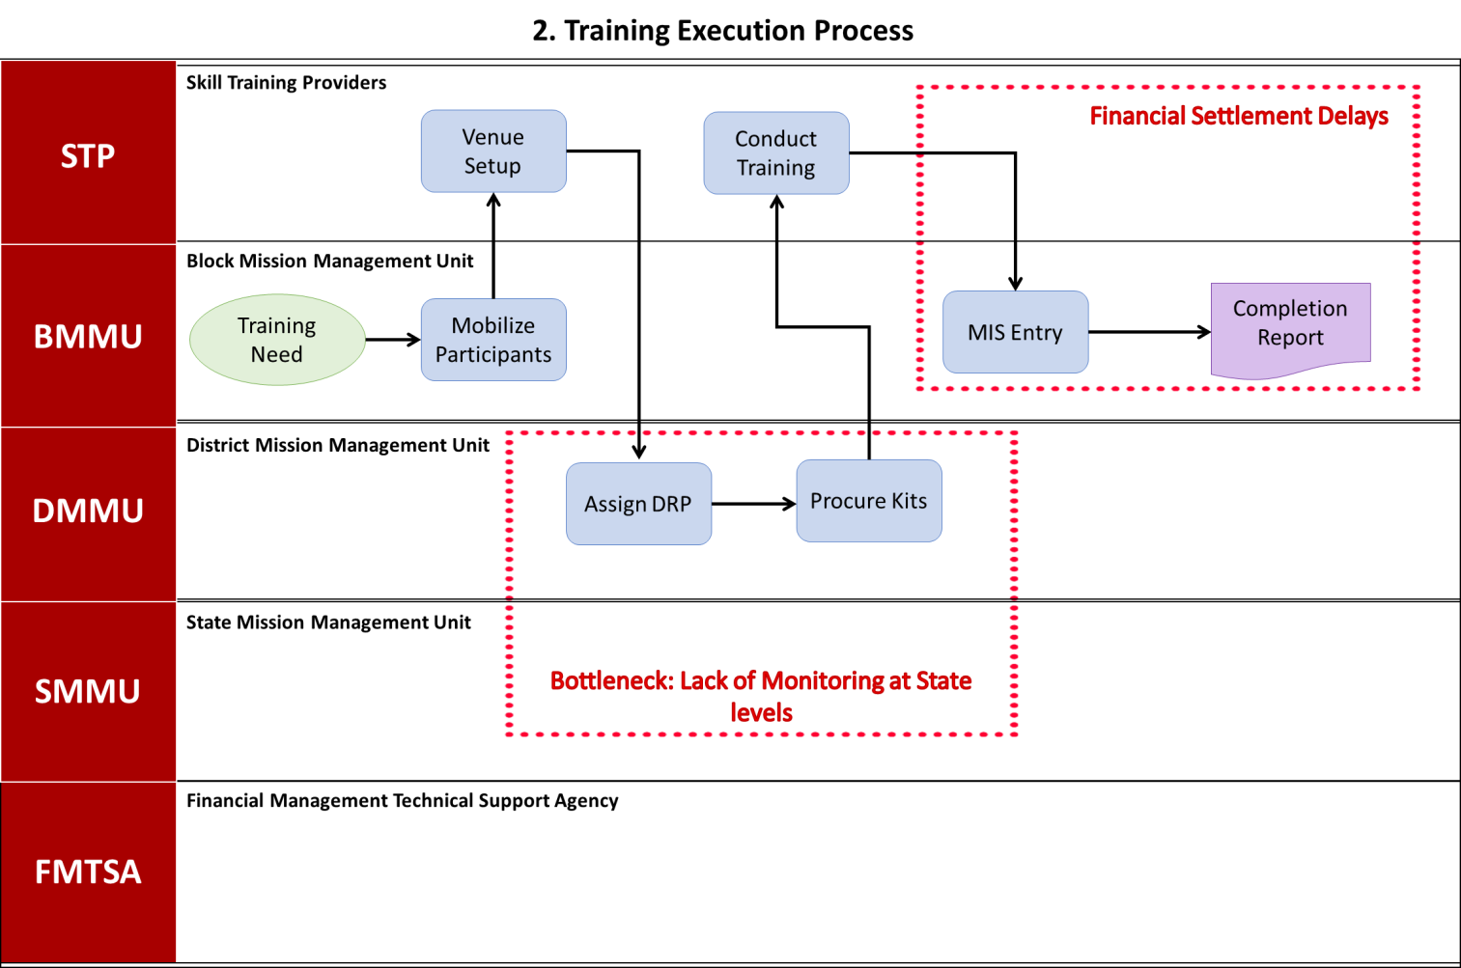

- Summary of Key Findings
- Total Process Steps: 21
- Decision Points: 1
- Identified Delays: 2
- Organizational Levels: 5 (VO/CLF, STP, BMMU, DMMU, SMMU, FMTSA)
This AS-IS process map provides a comprehensive overview of the UPSRLM Training Management System, highlighting areas that require attention to improve efficiency and effectiveness. Addressing the identified bottlenecks and delays will be crucial for enhancing the overall impact of the mission.

Disclaimer
- By reading the report, the reader accepts the terms and conditions mentioned hereunder.
- The scope of assignment is as per Contract between Third Party Auditor (BDO India LLP) and UPSRLM.
- This Report (“Report”) is prepared solely for the UP State Rural Livelihoods Mission (UPSRLM). This Report is intended for UPSRLM’s internal use only, subject to the terms and conditions mentioned therein may not be relied upon by other parties (“Third Party”). Neither this Report nor its contents may be distributed to, discussed with, or otherwise disclosed to any Third Party without the prior written consent of BDO India LLP (“BDO India” or “we” or “our” or “us”). Any other persons who choose to rely on these observations may do so entirely at their own risk.
- Our procedure and findings are based solely on the data, documentation, information and explanation that has been provided to us during the course of our engagement. In case, we come across information which may have bearing on the findings and observation made in this report subsequent to submission of report, we have no responsibility to update this Report. In circumstances, where any additional information become available from or with respect to the engagement to us, we would be glad to carry out additional procedure as may be separately agreed with the Client.
- The work carried out and analysis presented in this Report are based on the result of our discussion with representatives of UPSRLM and are not always supported by written documentation. We make no representation regarding the sufficiency of the procedures performed either for the purpose for which this engagement was sought or for any other purpose. Findings are based on circumstantial evidence and partially concluded in the absence of adequate supporting / documents.
- We have relied on the information provided by the UPSRLM and our observations are based primarily on the review of such information. In respect of the information in soft copy form received from the UPSRLM, no independent verification with the original documents is carried out.
- This Report does not constitute an engagement to provide audit, compilation, review, or attestation services made in accordance with the generally accepted auditing standards in India and, consequently, no assurance will be expressed. Our work would not be any expression of an opinion or testimony of expert witness. In any manner, the engagement does not extend to provide advice, analysis and observations relating to legal and regulatory issues.
- In no circumstances shall we be liable, for any loss or damage, of whatsoever nature, arising from information material to our work being withheld or concealed from us or misrepresented to us by any person of whom we made information requests at the bank or on field.
- BDO India LLP has executed detailed work steps as identified and agreed in our scope of work.
- We assume no responsibility for the accuracy and completeness of information, that cost/benefit and other considerations will preclude us from pursuing every conceivable source of information. Further, we have used professional judgment to identify the information source to be searched. If other professional undertook similar procedures on the same subjects, such professionals might provide different findings. Accordingly, we do not provide assurance that all information will be available in the public and private domain.
- UPSRLM shall be fully and solely responsible for applying independent judgment, with respect to the findings included in this Report, to make appropriate decisions in relation to the future course of action, if any. BDO India shall not take responsibility for the consequences resulting from decisions based on information included in the report.
- BDO has not identified, addressed or corrected any errors or defects in the computer systems, other devices or components thereof (“Systems”), whether or not due to imprecise or ambiguous entry, storage, interpretation or processing or reporting of data. We will not be responsible for any defect or problem arising out of or related to data processing in any Systems.
- Our reports and comments should not be considered a definitive pronouncement on the individual or the company.
- When assisting the Client in the Performance of BDO India’s activities, BDO India has not:
- Determined which, if any, recommendations should be implemented;
- Acted on behalf of management in reporting to the Board of Directors, or Audit Committee;
- Have custody of assets;
- Act in any capacity equivalent to a member of management or an employee;
- Assess the quality of source data;
- Held liable, for any loss or damage, of whatsoever nature, arising from analysis.
- Approved, or be responsible for, the overall fraud risk assessment work, including the ultimate assessment of review risk, determination of scope, project priorities and frequency of Performance of audit procedures.

WHAT MATTERS TO YOU,
MATTERS TO US.

FOR MORE INFORMATION:
Anurag Srivastava- Partner
+91 – 9717004947| AnuragSrivastava@bdo.in

BDO INDIA LLP, an Indian limited liability partnership, is a member of BDO International Limited, a UK company limited by guarantee, and forms part of the international BDO network of independent member firms.

BDO is the brand name for the BDO network and for each of the BDO Member Firms.
Copyright © Aug 2021, BDO INDIA LLP. All rights reserved.
www.bdo.in

